
TRAILSTAR INTERNATIONAL, INC
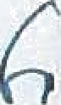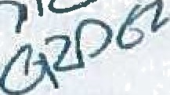20700 HARRISBURG WESTVILLE RD
ALLIANCE, OH 44609
Phone: (330) 821-9900
Website: W\M/\/.TRAlLSTARlNTL.COM

Tide affér is velfd until the printed expratlan date, and Is subject ta change at Manufac a dkcratlon ba•e‹l on ma4‹et condi\Ions

g m | PACE TRAILER | SALES & SERVICE |  | INC |  |  | balance Due |  | 190,420.00
/'/® • TRAILSTAR INTERNATIONAL, INC |  |  |  |  |  |  | Cublc Yards |  | 37
@ggg@ @g@ | 10/18/22 |  | Ouote Ezotzes | 11/18/22 | {Qty | 1 | guest |  | 20780 lbs. | ””*

Dealer Saleszoan | MARK FLETCHER | Model Code | HH | Plant of Mfg | R
Cust P.O. # |  | Just Unft # STK QUAD PACE

LENGTH WIDTH BODY STYLE FLOOR
RADIUS BOTTOId CROSSMEMBER TYPE

LOfiOfTtJDlNAL
FUR MATERIAL BODY HOLD DOWN VIBRATOR
REAR HINGE PIN WALL HEIGHT TOP RAIL
TOP RAIL OPTION

BOLSTER
REAB POCkET SLOPE
NO. OF INCHES TO EXTEND REAR POCKET REAR SKIRTS
FRONT SKIRTS HOIST
REMOTE GREASE BULKHEAD TYPE BULKHEAD LADDER BULKHEAD DOOR “ SIDES STEPS D.S. SIDES STEPS CS.
FOLD DOWN LADDERS DS. FOLD DOWN LADDERS C.S. SHOVEL HANGER
FRONT CAB SHIELD REAR END STYLE SIOES

06 IN. BODY W/102 IN. FRAME AND SKIRTS
SINGLE PIECE ”
1/4 IN. FULL ”
22 IN. HARDOX AR450F
3•1/2 IN. AR450 BOX ON 16 IN. CENTERS
4 XI X 1/4 SQ. TUBE HARDOX AR450F < NONE
NONE

STANDARD SINGLE ouMp sHoe
60
3/J6 IN. X4 IN. X 8 IN.
3 X 3 X 3/8 MOLE (ADD 2 1f4 lt'LTO WALL HElGHTj

(1) BprsTzR(s) 80"WH x 96"WIDE 0
NONE “
ALUktlNUM DIAMOND PLATE FULL LENQTH .
NONE ”
V235.-.CUSTOM
HSNEGLE F!O O EA I V/i

DQF U H DE NONE
STEEL LADDEI3 AT REAR
NONE ’
NONE " NONE "
YES, CURB SIDE 12 IN. CAB SHIELD SQUARED-OFF
SAME AS FLOOR (SINGLE PIECE)


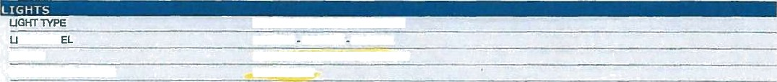
GHT PAN APRON
STD. MARKER MGHTS
TRUCXLfTE LJ2A. W/ DROhtMET 3 LARGE 3 LARGE 3 LARGE
3/8 IN*X4 IN: FULL'LIGHT SHIELD
4ICH SIDE
11/1f22 1:51 pin Pagc I of4

MID-TURNS
BACK-UP LIGHTS ” " "

AUXILIARY CABLE BACK-UP LIGHT WIRE REAR POCKET LIGHTS
. (1) PAIR I-ND:(CDMBO) NONE

+AUXILARY(BACK WIRE}
P to OF SMALL-(uooEc-so›e

GATE SHEET THlCkNGSS
1/4 IN. HARDOX AR450F
GATE OPERATION AIR CAB CONTROL @D BAI-LVALVE
T
v
o

HINGE TVPE COAL DOOR CHUTE
DOUBLE HANDLE OOOR GATE BRACING
HALF ROUND ON GATE ANGLE ON TOP OF GATE SPREADER CHAINS WINDERS / SAFETY LATCH TARP HOOKS
.FAIR ASSIST.HIGH LIFT (IN KET} NONE ” “*
NONE NONE
(4) PANEL "" YES
NONE
YES. W/ COVER
WINDERS (1) EACH SIDE (STEEL GATE} NONE

NO. OF PRIMARY AXLES ” ' 3 --*’
P ON HEN T W
AXLE SPACING 44
AXLE9 < AXLE FOR INTRAAX ONLY
BRAKES 7 IN. XL, W/ 30-30 CHAMBERS
CAM GUARDS HMD. INTRAAX
HUB AND DRUM *CAST”W/°GTEEL”HUB HP 10 STUO TP, D3, 7 IN.
TIRES <CONTINENTAL•HSR2 11R’W5'16 PkY
WHEELS | HP•2Z EXQ& | JDE | E
PRII'JARY AXLE TIRE INFLATION SYSTEM | NONE

NO. OF LIFT AXMS LIFT AXLE SUSPENSION IFT KIT
LIFTAXLE DISTANCE
LIFTAXLE MFTAXLE BRAKES
us/u‹re cau cuxnos
LIFTAXLE HUB AND DRUM LIFT AXLE TIRES MFTAXLE WHEEL6
RFP Afi -G CONTROLS

FREE WHEEL VALVE
MFT AXLETIRE INFLATION SYSTEM

NO. OF STEERABLE AXLES STEERABLE AXLE SUSPENSION STEERABLE AXLE DISTANCE STEERABLE AXLES
STEERABLE AXLE BRAKES STEERABLE LIFT AXLE LUBRICATION STEERABLE AXLE HUB AND DRUMS STEERABLE AXLE TIRES STEERABLE AXLE WI-tEELS

11/lf22 1:S1 ptn

HEND*lNTRAAX’AAt'25K (4) TIRES WMXL4
HEND. UBL-002 (INTRAAX AAL) 46
AXLE FOR INTRAAX ONLY _
7 IN. XL, W/ 30-30 CHAMBERS
HEND. INTRAAX
CAST W/ STEEL HUB HP 10 STUD TP, LS, 7 IN. CONTINENTAL HSRg 11R 2 5 16 PLY
QA &”S HP Z 5X8W- INSIDE S OUTSID LI ED QP)
_RUA\3A &' ALVE ’Q

NONE

NONE
N/A NONE NONE NOHE NONE NONE I4ONE

P• gr 2 of4

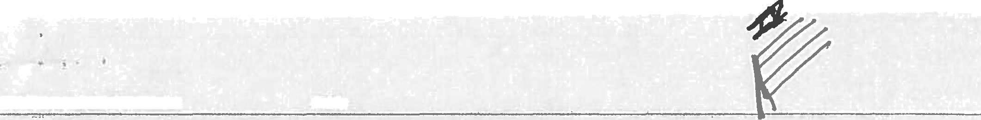
STEERABLE AXLE CONTROLS
NONE

FRAME RAILS 17'iN 0MIMJM°BB
RUBBER ON FRAME RAILS ”3B IN. RUBBER-
NO. OF INCHES FOR GOOSENECK NO GOOSENECK, 9W I.O. IN. HEIQHT
LID FOR GOOSENECK NONE
PIN SETTING 18
STH WHEEL PLATE “ 3/8
6TH WHEEL PLATE HEIGHT 49 IN. HIOH KING PIN " ” KING PIN
NO. OF INCHES FOR REAR OVERHANG 7
TRACTOR DRIVE MODEL TANDEM DRIVE
GALVANIZED SUSPENSION HANGERS YES
STIFFENER PLATE NONE
HOIST 6 NOUNT STYLE 3 IN. X 8 IN. X 3/8 IN.
SUSPENSION CONTROL *AIR IN€AB &‘BALL VALVE
ABS FOR TRAILER (1) 2S1M MERITOR / WABCO ”
SLACtfS AUTOMATIC
CHRDME TOP HATS NONE
AXLE LUBRICATION SYNTHETIC SEMkFLUID GREASE ODOMETER NONE
DUSTCOVERS t4ONE
TIRE CARRIER(S) NONE
DOLLIES - LANDING GEAR - LANDINQ LEGS JOST AX-150 - (55,000 LB.) - 10 YEAR ALUMINUM - D.S. REGISTRATION HOLDER NONE
AIR GAUGE / SYSTEM NONE
ENCLOSURE FOR SWITCHES POLYMER ”
AIR TANKS ALUMINUM.TANK
HYDRAULIC HOSE FITTING 1 IN. 108 IN:*HOSE'W/.F M LE¿QUICK CONNE {BARKER)
FLAPS FRONT OF TIRES igSHORT•F’LAP'IN FRONT OF-FRONT'AKLE S R F RES FsU C OF T LE
TOW/ PINTLE HOOKS NONE
BUMPER ” H.D. MICHIGAN”BUMPER"

TARP MANUFACTURER
TARP CONTROL

TARP COLOR BOW HOLDERS TARP BRACKET

SUSPENSION COLOR DOLLIES
HOIST COLOR
5TI4 WHEEL PLATE COLOR FRAME COLOR
BODY COLOR TRAILSTAR LOGOS OPTIONAL SIGNS

‘ e I
LOAD LEVEL INDICATOR
NONE NONE NONE

BLACK SOFT COAT BLACK(631716) BLACK (831716) BLACK (S31716) NONE
>BLACK
TRAILSTAR BLACK MACHINE LOGO BLACK (930248) NONE

NONE

 P.age 3 cf4

ial cost i
deliver
start of production.

Quote P/ice $90,220.00

Addtl $$ fér Changes 3i200.00
Discount Taken 50.00

Qtzote & 77969
job#
FET 50.00
Sales Tax 50.00
SU TOTA
Freight $0.00
TFQOB AC T
Trade In Allowance 50.00
Down Payment f•0.00

Pricing Is In U.S. Currency NCE UE

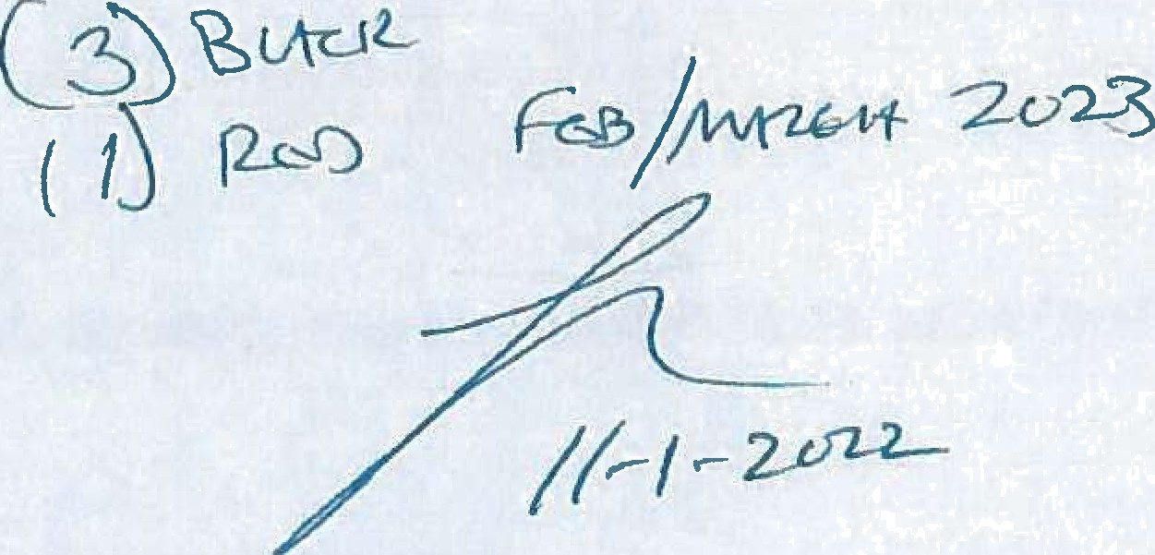

ORD£A CANNON POIJCV
••• denotes a welght for reference only. drafter weight will be provided wlth the engineering dcslgn approval packnh




